**Read Security Token/ Parameter From URL**

Here we will read values from API URL that will pass parameter in the URL along with Body Content while passing from Postman

**Summary:**

* Creating a MS Flow that will read data passed from other application send Approval Card in Outlook email
* Read parameter value form “**URL** ” along with “**Body**” in the API passed from Postman
* 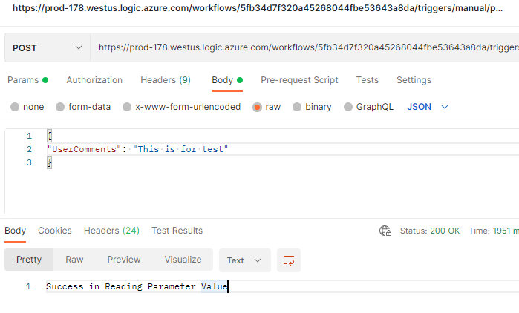

Create New Workflow with template as “When request received”

Define the JSON Schema as:

{

"UserComments": ""

}

Advance Mode > Provide relative path as : **document/{SecurityToken}**

**Add new compose action, and you can read this parameter value and body value**

## Validate from Postman:

## Copy the URL of the When a request received and replace the “SecurityToken” value as below

## [https://prod-178.westus.logic.azure.com/workflows/5fb343a8da/triggers/manual/paths/invoke/document/{SecurityToken}?api-version=2016-06-01&sp=%2Ftriggers%2Fmanual%2Frun&sv=1.0&sig=V0DSAm9e7rtNA_9A251X7Jm5gWx2Vyd7KNbUrO5iOJk](https://prod-178.westus.logic.azure.com/workflows/5fb343a8da/triggers/manual/paths/invoke/document/%7bSecurityToken%7d?api-version=2016-06-01&sp=%2Ftriggers%2Fmanual%2Frun&sv=1.0&sig=V0DSAm9e7rtNA_9A251X7Jm5gWx2Vyd7KNbUrO5iOJk)

## New URL should be as:

## [https://prod-178.westus.logic.azure.com/workflows/5fb343a8da/triggers/manual/paths/invoke/document/{myCustomToken}?api-version=2016-06-01&sp=%2Ftriggers%2Fmanual%2Frun&sv=1.0&sig=V0DSAm9e7rtNA_9A251X7Jm5gWx2Vyd7KNbUrO5iOJk](https://prod-178.westus.logic.azure.com/workflows/5fb343a8da/triggers/manual/paths/invoke/document/%7bmyCustomToken%7d?api-version=2016-06-01&sp=%2Ftriggers%2Fmanual%2Frun&sv=1.0&sig=V0DSAm9e7rtNA_9A251X7Jm5gWx2Vyd7KNbUrO5iOJk)

## O/P from Postman

